**Setting up Application Environment**

**Install IBM Cloud CLI**

|  |  |
| --- | --- |
| **Team ID** | PNT2022TMID52529 |
| **Project Name** | Inventory Management System |
| **Date** | 24 OCT 2022 |

**Step 1:** First login with **cloud.ibm.com.**

Next search with Container Registry in IBM search catalogue

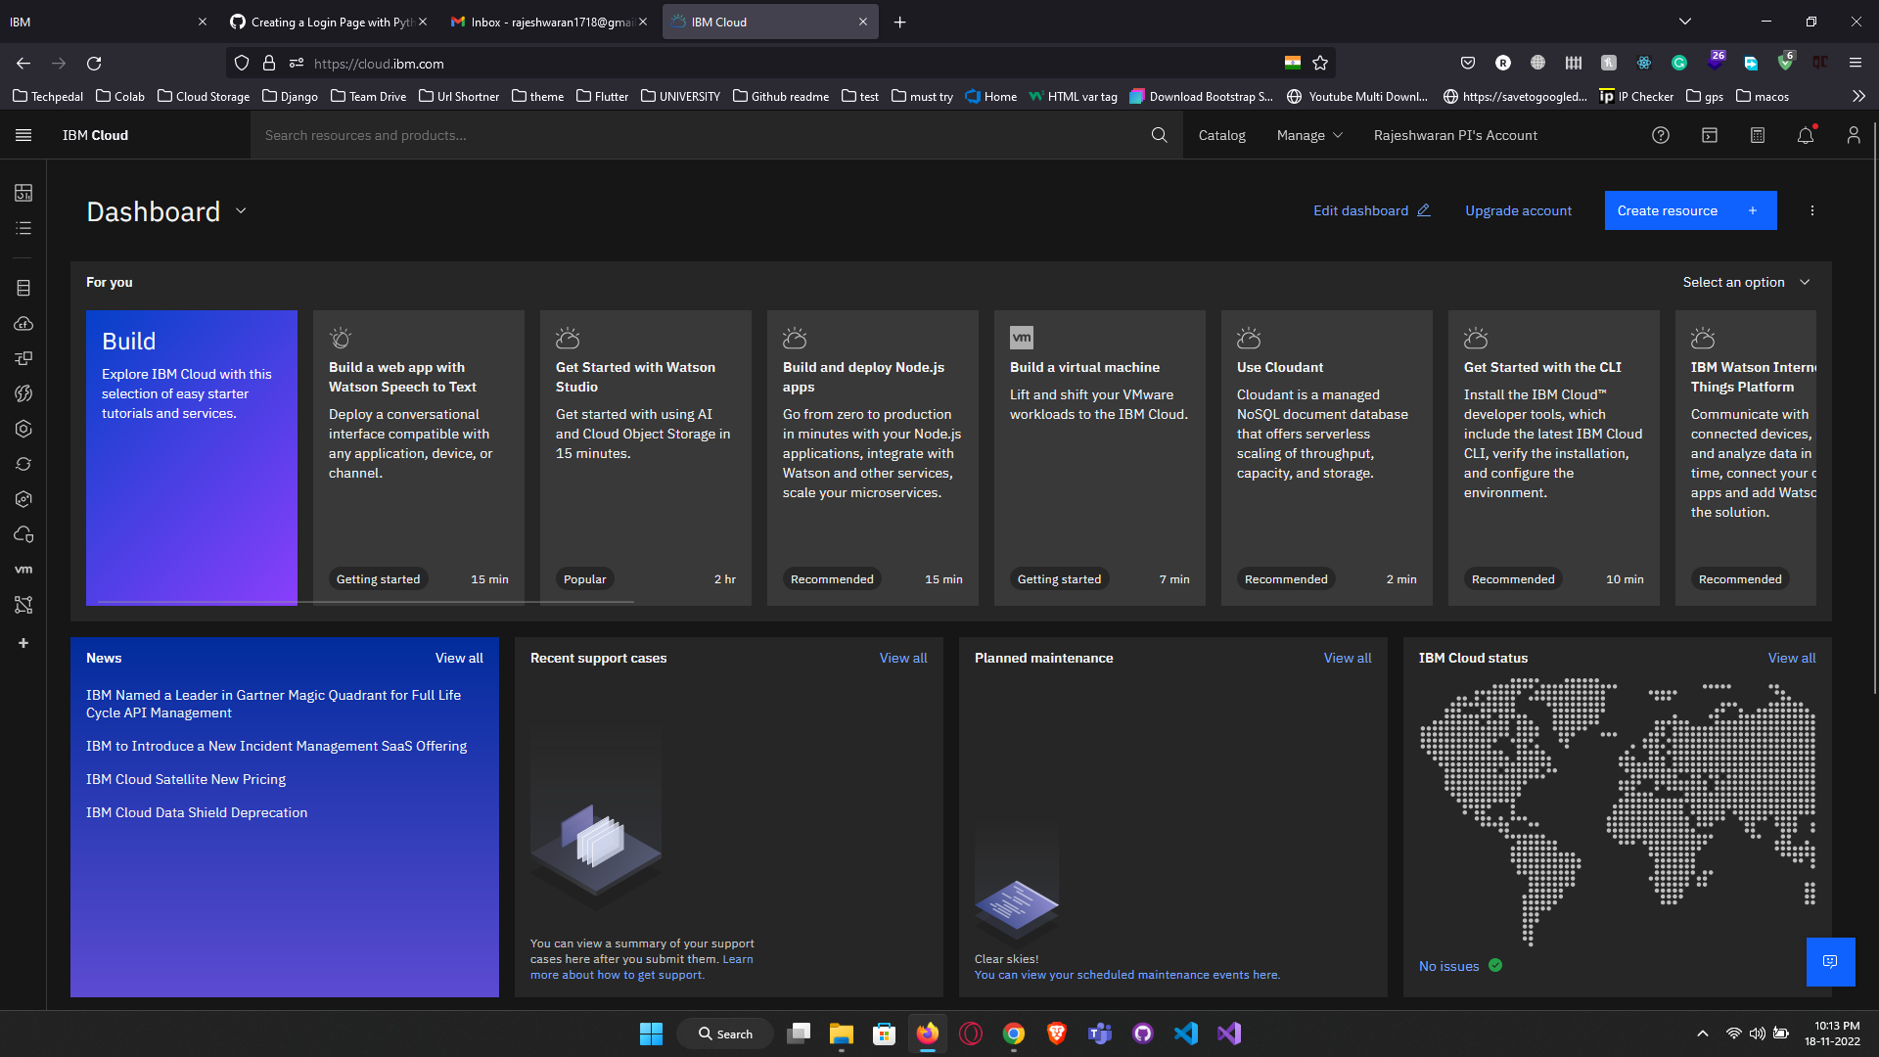

**Step 2:** Install the IBM Cloud CLI

**Step 3:** In cloud CLI there is list of commands insert the into our windows command prompt

